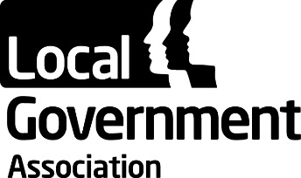 | Safer and Stronger Communities Board
 | 03 September 2018

Appendix D – List of Future Safer and Stronger Communities Board Meetings for 2018/19

Future meetings of the Safer and Stronger Communities Board will be held on:

- Monday 12 November 2018; 11.00 am – 1.00 pm

- Monday 14 January 2019; 11.00 am – 1.00 pm

- Monday 18 March 2019; 11.00 am – 1.00 pm

- Monday 10 June 2019; 11.00 am – 1.00 pm

All meetings will be held in Smith Square 1&2, Ground Floor, 18 Smith Square, London, SW1P 3HZ.

